Capstone Project 1

Following are the specifications of the lifecycle:

1. Install the necessary software on the machines using a configuration management tool.

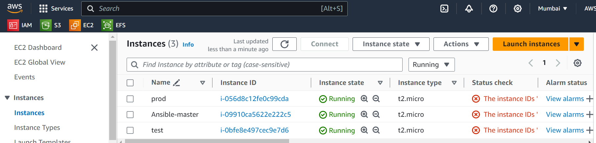

1 sudo apt update

2 sudo apt install software-properties-common

3 sudo add-apt-repository --yes --update ppa:ansible/ansible

4 sudo apt install ansible

5 ansible --version

6 cd .ssh

7 ls

8 ssh-keygen

9 ls

10 nano id_rsa.pub

11 cat id_rsa.pub

12 ansible -m ping all

13 cd

14 cd /etc/ansible

15 cd hosts

16 sudo nano hosts

17 ansible -m ping all

18 sudo nano play.yaml

19 sudo nano master.sh

20 sudo nano slave.sh

21 ansible-playbook play.yaml --syntax-check

22 ansible-playbook play.yaml --check

23 ansible-playbook play.yaml

24 cd

25 ls

26 cd /etc/ansible

27 ls

28 sudo nano play.yaml

29 sudo nano master.yaml

30 ls

31 sudo rm master.yaml

32 ls

33 sudo nano master.sh

34 sudo nano slave.sh

35 ansible-playbook play.yaml --syntax-check

36 ansible-playbook play.yaml --check

37 ansible-playbook play.yaml

38 java --version

39 jenkins --version

40 cd

41 cat /var/lib/jenkins/secrets/initialAdminPassword

42 sudo cat /var/lib/jenkins/secrets/initialAdminPassword

43 cd

44 history

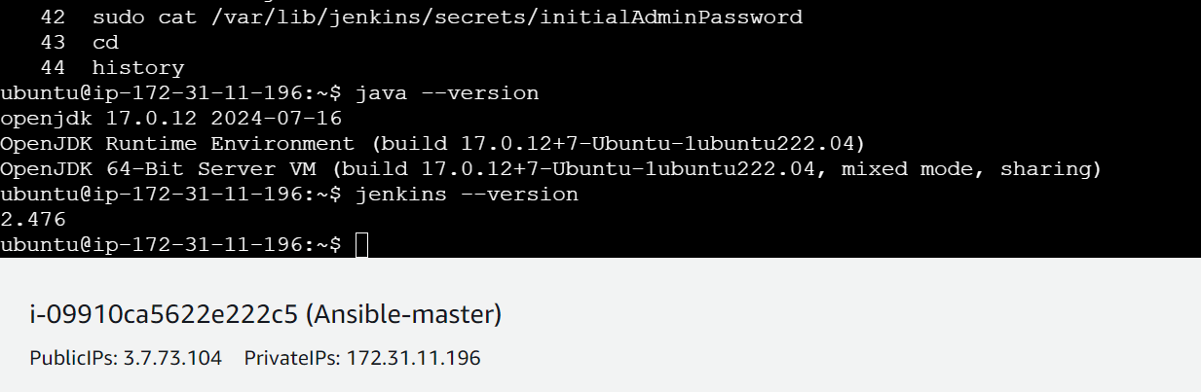

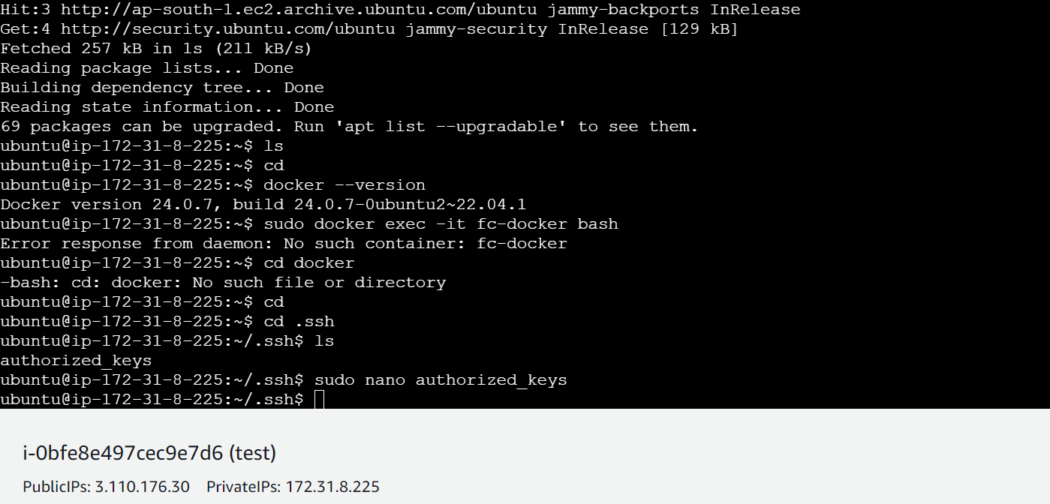

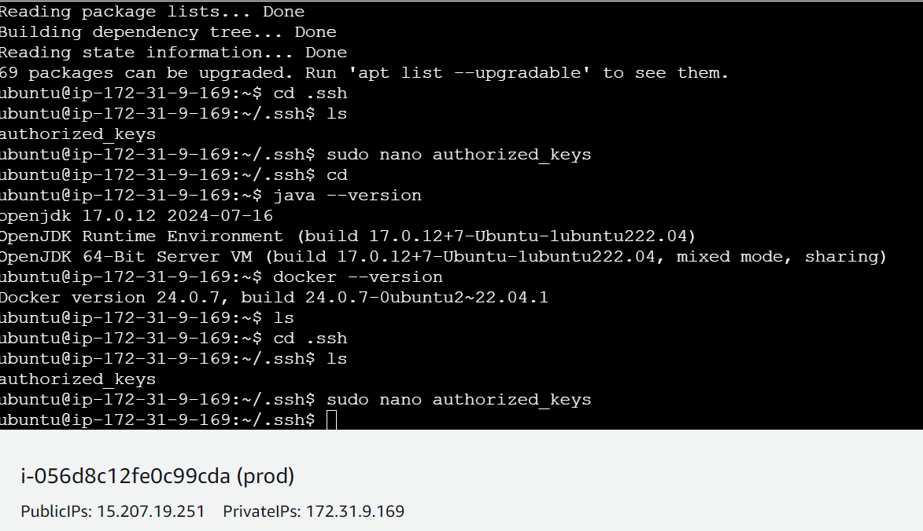

Play.yaml –

---

- name: master tasks

hosts: localhost

become: true

tasks:

- name: execute tasks for master

script: master.sh

- name: slave tasks

hosts: all

become: true

tasks:

- name: execute tasks for slave

script: slave.sh

master.sh –

sudo apt update

sudo apt install openjdk-17-jdk -y

sudo wget -O /usr/share/keyrings/jenkins-keyring.asc \

https://pkg.jenkins.io/debian/jenkins.io-2023.key

echo "deb [signed-by=/usr/share/keyrings/jenkins-keyring.asc]" \

https://pkg.jenkins.io/debian binary/ | sudo tee \

/etc/apt/sources.list.d/jenkins.list > /dev/null

sudo apt-get update

sudo apt-get install jenkins -y

slave.sh –

sudo apt update

sudo apt install openjdk-17-jdk -y

sudo apt install docker.io -y

1. Git Workflow has to be implemented

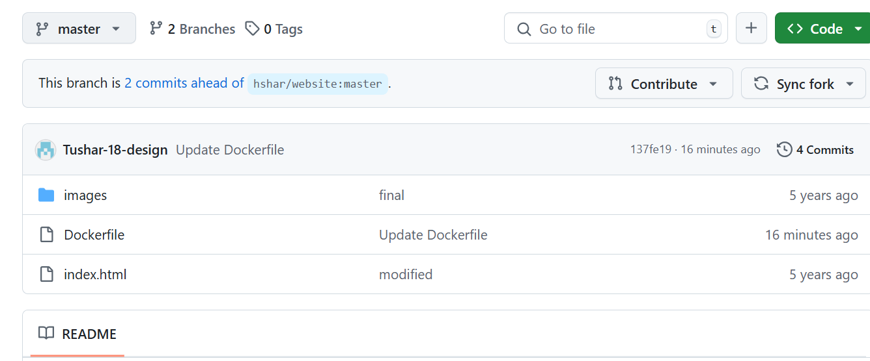

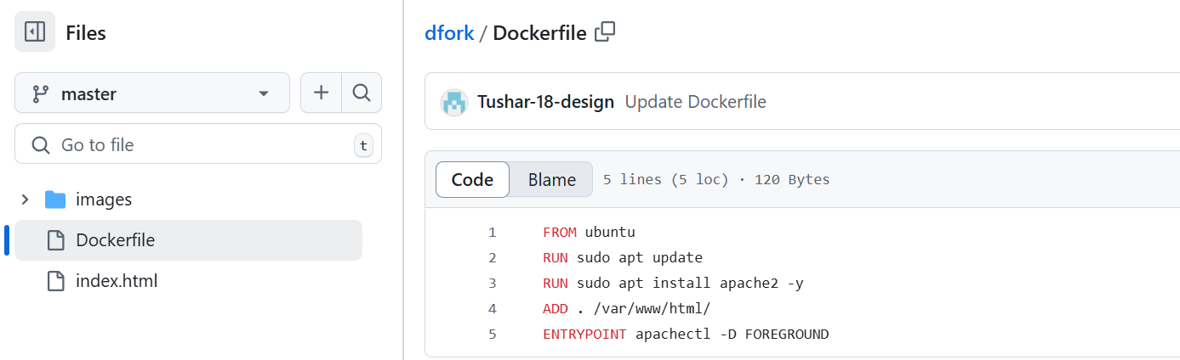

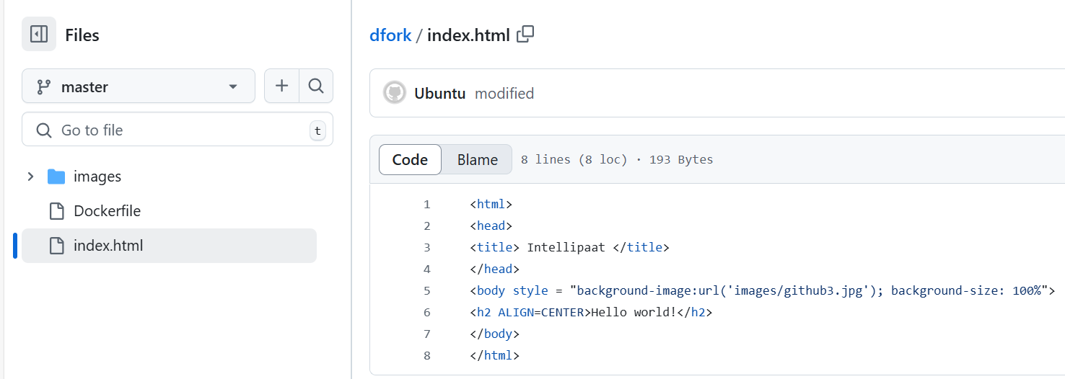

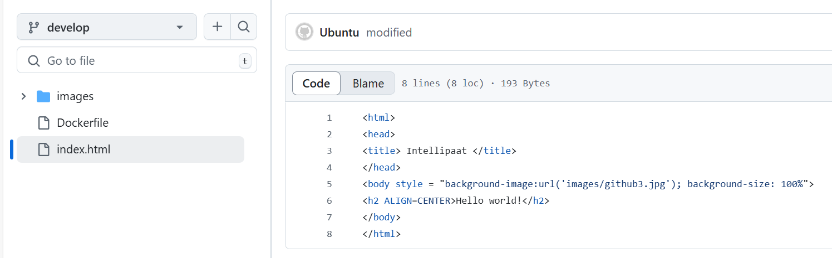

3.Code Build should automatically be triggered once commit is made to master branch or develop branch. If commit is made to master branch, test and push to prod If commit is made to develop branch, just test the product, do not push to prod

Job1

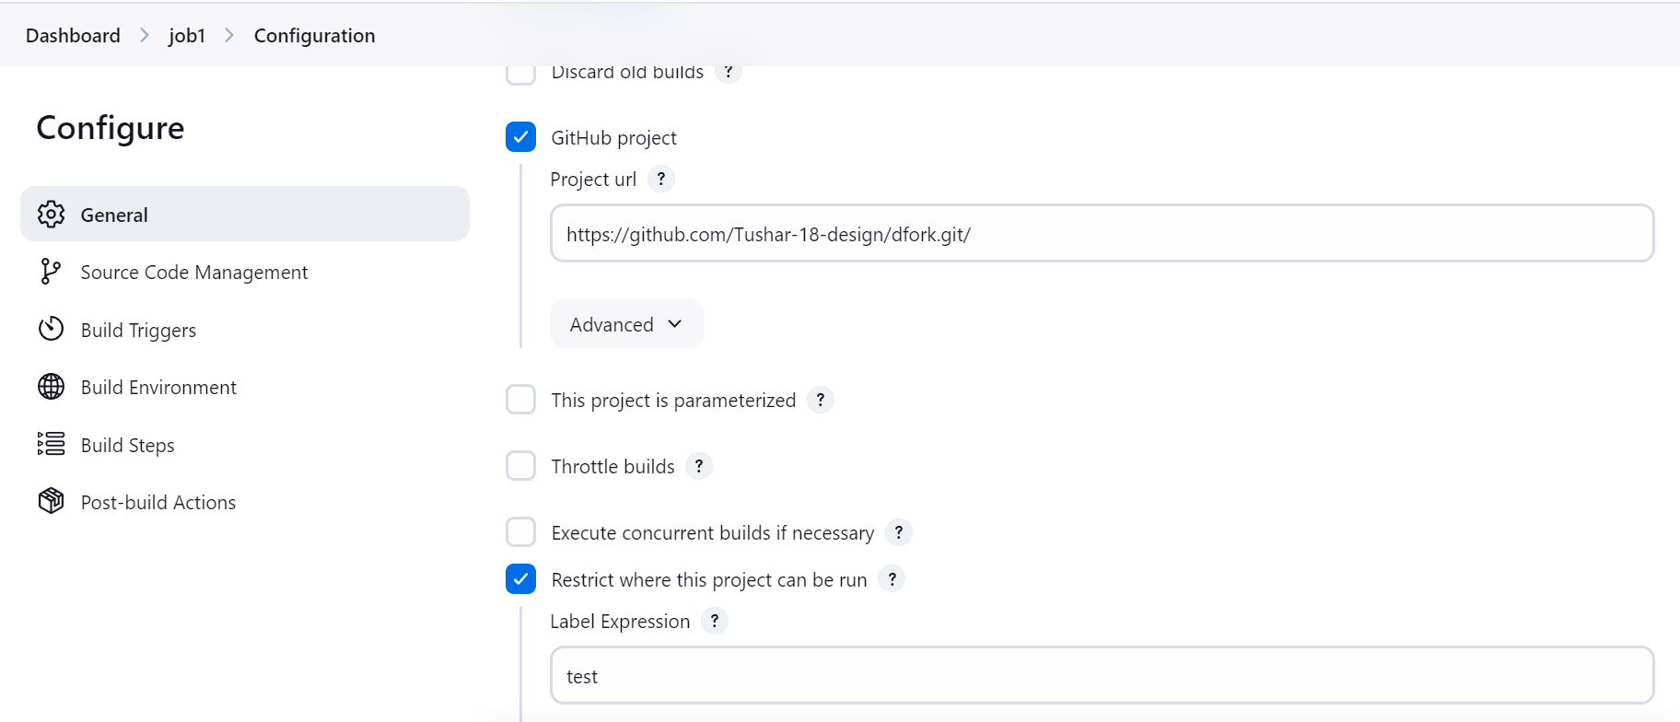

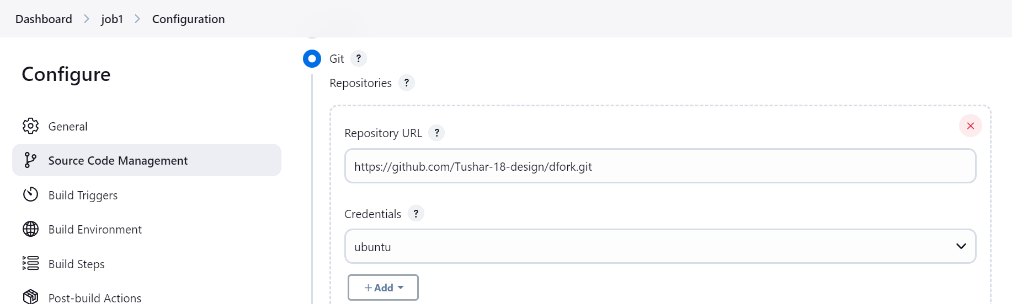

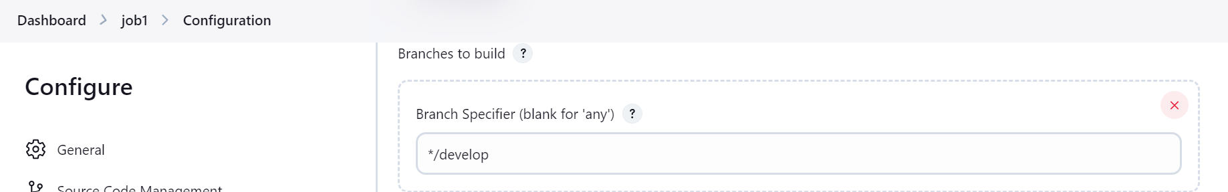

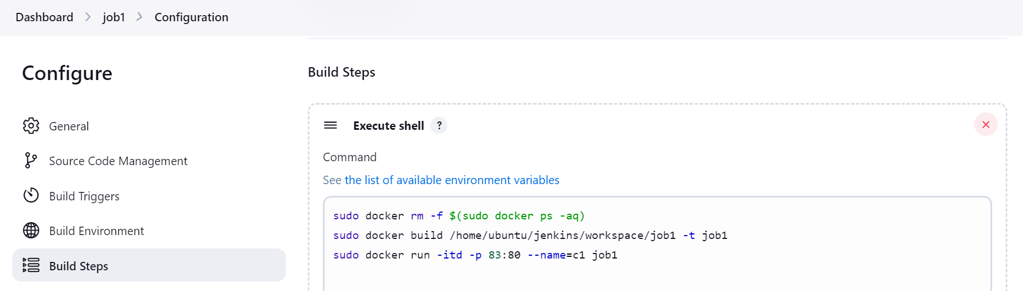

Similarly, job2 and job3 are build.

4.The Code should be containerized with the help of a Dockerfile. The Dockerfile should bebuilt every time there is a push to Git-Hub. Use the following pre-built container for your application: hshar/webapp The code should reside in '/var/www/html'



5.The above tasks should be defined in a Jenkins Pipeline, with the following jobs: Job1 : build Job2: test Job3 : prod

